1. 74175 quad D flip flop ICs (total 3 used)
#SN74175N
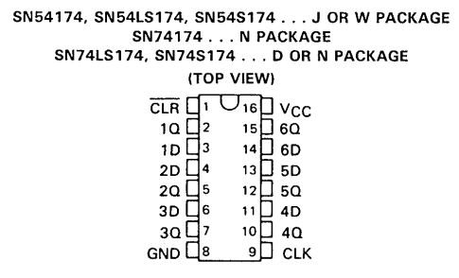
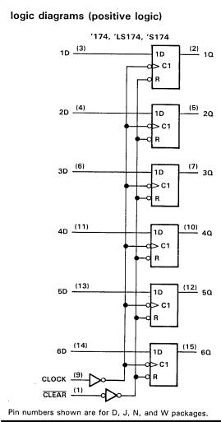

2. 74139 1*4 DeMux/Decoder IC (1 used)
#74139
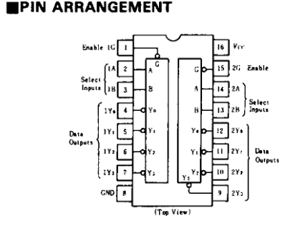
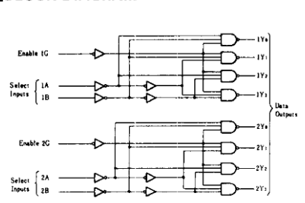
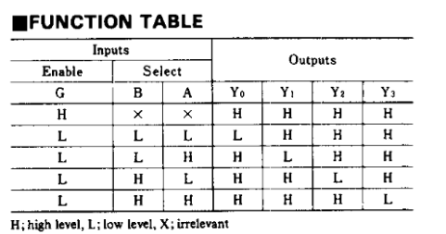

3. 74153 4*1 Mux IC (total 4 used)
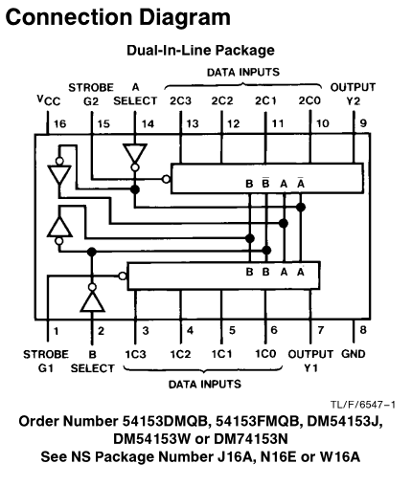

4. 7408 quad AND gate (1 used)
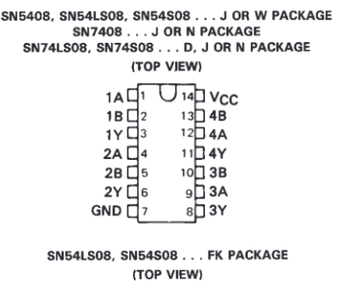
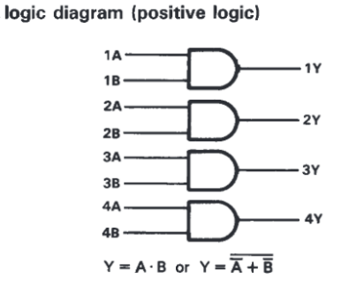

5. Push button pulse generator
6. Jumpers and hook-up wires.
7. Toggle Switches (total 6 used)
8. LEDs (total 4 used)
9. Breadboards (3 used)

